IHE Work Item Proposal (Detailed)

# Proposed Work Item: Structured Data Capture Content Profile

Proposal Editor: Evelyn Gallego, Vijay Shah, and Hector Cintron

Work item Editor: Evelyn Gallego, Vijay Shah, Hector Cintron, and George Cole

Date: November 3, 2013

Version: 1.0

Domain: Quality, Research and Public Health

# Summary

As the use and adoption of electronic health records rises globally, the volume and detail of information captured by healthcare organizations and providers is growing exponentially. A Structured Data Capture (SDC) Content profile will provide uniformity to the specifications by which disparate EHR systems capture, store, retrieve and exchange data.

The SDC Content profile provides a secure method for which IHE Retrieve Form for Data Capture (RFD) can be utilized, along with additional Common Data Element (CDE) guidance and Meta-model for Framework Interoperability (MFI) form compliance, for exchanging EHR data

The Office of the National Coordinator (ONC) Standards & Interoperability (S&I) SDC Initiative has developed an extensive Use Case document, identified national standards for the structure of CDE’s and Form Model definition, developed guidance to assist in implementation and prepared pilots for evaluation of SDC.

An IHE profile is intended to provide implementation guidance for a set of standards from disparate sources. SDC will build upon the RFD base standard and as a profile could reference or be referenced by other IHE profiles, white papers or supplements.

# The Problem

*Problem Statement*: The utility of EHR data for supplemental purposes has been limited due to a lack of uniformity in the terminology and definitions of data elements. This limitation is compounded by the fact that clinician workflow often records patient information in unstructured free-text data well after the episodes of care. Linking EHR data with other data in a uniform and structured way will accelerate quality and safety improvement, population health and research. The SDC consensus-driven community wants to reuse and provide additional constraints on IHE RFD for the Use Case described, as has been done before with CRD.

The SDC Content profile will define: 1) the structure for Common Data Elements that will be used to fill the specified forms or templates, 2) the structure or design of the form or template (container), 3) how EHRs interact with the form or template, and 4) auto-population of a form or template. The SDC Content profile will expand on the RFD Profile by defining a secure RFD (transactions and auditing) as well as profiling definitions for a Form instance, for Data Element to Form Element mapping, and for submitting completed Form Data.

The infrastructure will consist of four new standards (or guidance) that will enable EHRs to capture store, and exchange structured data leveraging defined standards and formats. These will consist of:

* A standard for the CDEs that will be used to fill the specified forms or templates;
* A standard for the structure or design of the form or template (container);
* A standard for how EHRs interact with the form or template – reusing/constraining RFD;
* A standard to enable these forms or templates to auto-populate with data extracted from the existing EHR.

*Value Statement:* SDC supports vision to design the trusted mechanisms to enable patient information to flow securely from the system it was collected—the EHR—to other systems, research consortia, registries, bio repositories and public health systems, with an authorized use for it. The identification and harmonization of standards for structured data capture within EHRs will not only help achieve this vision, but they will also help reduce the:

* Data collection burden on health care providers by enabling secure, single-point data entry that populates to multiple systems
* Need to make site-specific modifications to EHR system capabilities in order to enable participation in important reporting and research activities
* Barriers to volunteer adverse event reporting on medical products to public health agencies leading to improvements in population health

The SDC Content Profile will expand upon a natural stack that exists for future Content Profiles needing IHE RFD. It will provide a Secure RFD (transactions and auditing) exchange in one Profile. Future Content Profiles using RFD may leverage this profile and will need only their domain specifics information be added to the profile.

Figure : IHE Profile Building Blocks

This work will align with federal partner’s strategic objectives including Office of the National Coordinator for Health IT (ONC), National Library of Medicine (NLM), Agency for Healthcare Research and Quality (AHRQ) and the already existing work under the SDC initiative including a SOAP/SAML Implementation Guide to be adopted as an artifact.

# Use Cases

The SDC Initiative developed a general use case that could be applied to 4 scenarios: clinical research, patient safety and adverse event reporting, and documentation of coverage. The generic use case is described below:

A Provider has identified a patient with a reportable condition. Using an existing EHR system, the Provider requests appropriate form electronically from the jurisdictional public health organization or entity. The EHR System (using Form Filler) sends information already collected about the patient to a Form Manager. At the time of the request, the EHR indicates what archive option, if any, should be used. The archive maintains the data as read only so they are an indisputable and auditable record of the reporting. The archive may be maintained by the EHR or by an independent service on behalf of the provider. The archive option specifies information necessary to connect to the archive and may include any combination of the following: the information that was sent with the request; the form template; the form data returned after being auto-populated; and/or the form data as they were submitted.

The Provider now sees the jurisdictional public health reportable condition form inside his or her own EHR system. Conveniently, the EHR system (using Form Manager, Metadata Consumer, and Metadata Source as applicable) pre-populated most of the data in this form. The Provider verifies the pre-populated data, adds any missing data, and then submits the form.

The Provider receives a response that confirms that the report was submitted to Public Health electronically and received by the public health information system. If an archive option was specified then the response also confirms that the requested archive was created. A week after the report was made a question arises regarding the report. The provider is able to access the archived data (subject to appropriate security and confidentiality constraints) to document the submission; review the submission; and/or regenerate an exact copy of the submission.

Figure : SDC Generic Use Case diagram

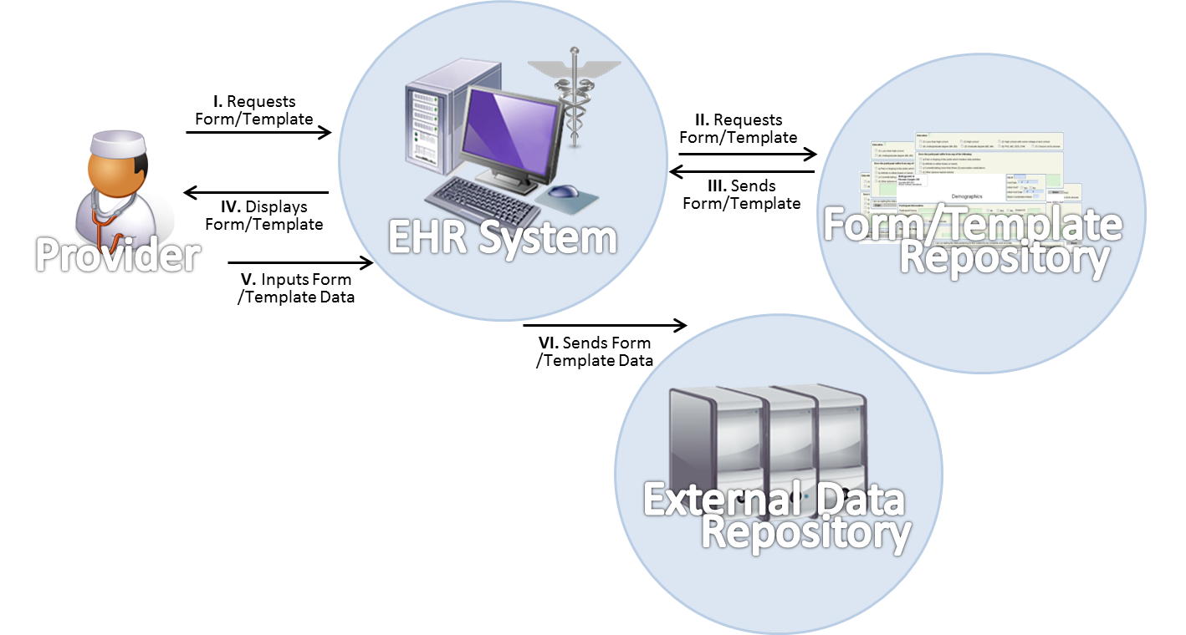

# Standards & Systems

The S&I SDC community went through [extensive standards selection process and consensus-building](http://wiki.siframework.org/Structured+Data+Capture+Use+Case+Harmonization+and+Standards+%28Implementation%29) to come to the final technical solution based on five information interchange transactions.

Content and Structure

* [CDA Consent Directives](http://www.hl7.org/special/committees/projman/searchableprojectindex.cfm?action=edit&ProjectNumber=553)
* [ISO/IEC 11179](http://metadata-standards.org/11179/)
* [ISO/IEC 19763-13](http://www.iso.org/iso/home/store/catalogue_tc/catalogue_detail.htm?csnumber=63474)
* [IHE DEX](http://www.ihe.net/Technical_Framework/upload/IHE_QRPH_Suppl_DEX_Rev1-0_PC_2013-06-03.pdf)

Transport, Security, and Authentication

* IHE RFD
* [IHE ATNA](http://wiki.ihe.net/index.php?title=Audit_Trail_and_Node_Authentication)
* [SOAP](http://en.wikipedia.org/wiki/SOAP)
* [TLS v1.0 or higher](http://en.wikipedia.org/wiki/Transport_Layer_Security)
* [SAML](http://en.wikipedia.org/wiki/Security_Assertion_Markup_Language)

# Technical Approach

This solution leveraged experience and usage patterns for forms developed and implemented from efforts such as those represented by Retrieve Form for Data (RFD) profiles developed and promulgated by Integrating the Healthcare Enterprise (IHE). RFD has been used in some clinical care settings, administrative reporting settings, and in FDA-regulated clinical research.

Of critical importance to the SDC Initiative when formulating the solution plan and technical approach, was the identification of a form standard that would be technology and platform neutral, in keeping with the diversity of user and uses for structured data capture from EHRs. In adopting the RFD profile for retrieval of forms, the SDC Initiative builds upon successful use of profile in conjunction with HTML to describe both the content and presentation of forms. While an entire body of tools and technologies is associated with HTML, there was also a clearly identified need to have available a standard definition of the contents of a form and the data elements used within these forms. The technical approach is very modular, whereby a form, defined in xml can also be exchanged in HTML format. At the time of this submission, the standards associated with form definition and transmission using RFD are in development; final resolution is expected in near-term.

This sequence diagram below shows the flow of information for SDC:

Figure : SDC Process Flow



The details of three SDC transactions along with selected standards are further described in Appendix A.

**New actors**

No new Actors

**Existing actors**

Form Filler

Form Manager

Form Processor

Form Archiver

Form Receiver

Metadata source

Metadata consumer

**New transactions (standards used)**

No new transactions

**Impact on existing integration profiles**

SDC Content Profile is essentially an IHE RFD profile with added capabilities.

This content profiling raises awareness of the need to publish RFD grouped with ATNA as one profile document to be referenced by other content profiles.

For now, ATNA work will be embodied inside SDC content profile.

**New integration profiles needed**

In the future, a separate Secure RFD profile may be required.

Once such a profile becomes available, SDC Content Profile will reference it appropriately.

**Breakdown of tasks that need to be accomplished**

1. Specify Common Data Element definition and use
2. Specify MFI Form Model definition and related schema
3. Specify Transaction document sections and details
   1. Specify name-value pairs
4. Specify auto-population guidelines
5. Specify supporting document details
   1. Administrative Document details and sample XML
   2. MDR-Mapping Document details and sample XML
   3. Compliance Rule Document and sample XML
   4. Form Design Document and sample XML
6. Specify the grouping or binding to ATNA for all transactions
   1. Document the Audit Log messages for each transactions
7. Specify the grouping or binding to XUA (SAML assertion profile)

# Risks

One of the base standard – ISO 19763-13 (Metamodel for Form Registration) is currently going through balloting process and is expected to become a Draft International Standard by mid-2014. The SDC Content profile may need to be updated depending on the revisions that emerge following the ISO 19763-13 ballot reconciliation.

# Open Issues

* Although, SDC profile is based on the RFD profile, it has two new components – Security and Form data. Sufficient time will be required to ensure that these components map very well to extend the base RFD profile
* Need to consider how Common Data Element (CDE) definition will be integrated within the profile

# Effort Estimates

A moderate level of effort is estimated to develop this profile since it will build on the current model provided by IHE RFD and will leverage the SDC Implementation Guide document and other related artifacts developed under S&I Framework’s SDC Initiative.

# Appendix A: SDC Transactions

This section discusses the structured data capture flows for three types of transactions:

Figure : Form/Template Transaction without Patient Data

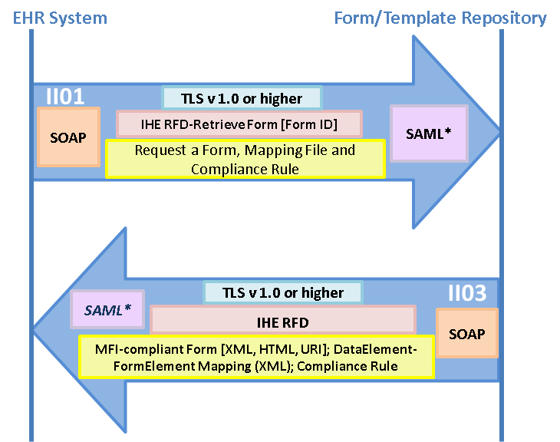

* **Form/Template Transaction without patient data** : the form/template transaction graphic (see Figure 3) show exchanges wherein an EHR requests and receives a blank form from a Form Template Repository;
  + **Exchange II01:** EHR System sends request for a form to Form/Template Repository
  + **Exchange II03:** Form/Template Repository sends the requested blank form to EHR along with Mapping file (optional) and Compliance Rules (optional)

Figure : Form/Template Transaction with Patient Data

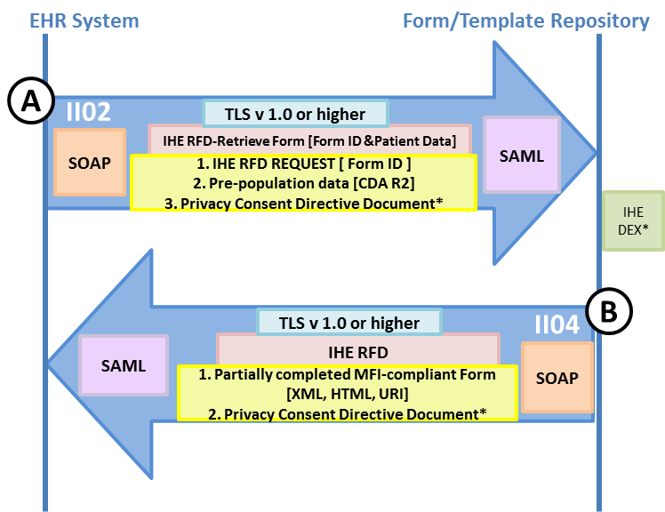

* **Form/Template Transaction with Patient Data**: the form/template transaction with patient data graphic (see Figure 4) show exchanges wherein an EHR requests a form and provides data that can be used by the Form Template Repository to auto-populate values in the form prior to the form being returned;
  + **Exchange II02:** EHR sends request for a form with some patient data to Form/Template Repository along with relevant patient consent directive documents (optional)
  + **Exchange II04:** Form/Template Repository sends back partially-filled (using the patient data from the request) MFI-compliant form along with Mapping file (optional), Compliance Rules (optional) and relevant patient consent directive documents (optional)

Figure : Complete Form/Template Structure Data Transaction

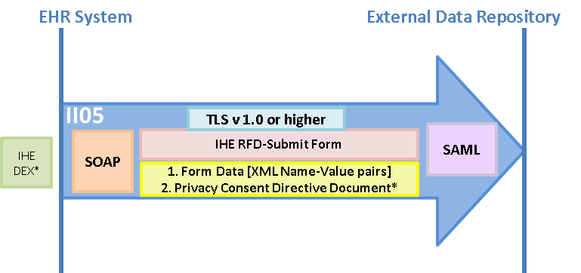

* **Complete Form/Template Structure Data Transaction**: the complete form data transaction graphic (see Figure 5) shows an exchange that conveys the data captured on a form to an External Data Repository.
  + **Exchange II05:** EHR systems sends the structured form data to an External Data Repository